**Client-side Environment:**

1. Java 7
2. Android SDK
3. Minimum SDK Version – 16
4. Compile SDK Version - 26
5. Target SDK Version - 26
6. Android Studio – 3.0

**Mobile Screens:**

**Splash Screen:** This is the first screen that gets displayed once the app is loaded.

This screen shows the app logo for a second and moves on into the app.

**Login Screen:** If the user/patient is not logged into the system, this screen is shown after the splash screen. Client and Server-side validations are taken care here, and thus only valid/registered patients are allowed into the app using the login authentication.

**Home Screen**: Home Activity is the screen that user gets to see once he/she logs in using their credentials. The home screen shows the Inbox with all three different kinds of messages present in the users’ inbox. This is the screen where user will be able to view and respond to his/her messages. The screen also has a search options that helps the user in searching for a message from a group of messages present. However, user can even navigate to other screens of the app from here, by utilizing the navigation drawer. This option is found as a hamburger icon on the top left of the screen.

**Profile Screen:**  This screen opens, when the user clicks on the Profile option of the navigation drawer. Profile screen shows the basic details of the user, and gives the option to update his notification preferences. Notifications are received by the logged in user only if he/she selects this option available.

**Survey Screen:**  When the user chooses to start a survey, that is sent to him, then, he/she clicks on the Start Survey button in the inbox. This will now take the user to the Survey screen where the user will be able to read about the survey and start the survey by clicking on the Start My Survey button. This way, all the surveys questions are displayed to the user and he/she can answer them accordingly.

**Send Feedback:** When a user wants to submit any feedback regarding the functionality of the app, or their own experience with the app, then the user can utilize the Send Feedback option on the navigation drawer to send an email stating their troubles/experiences with the app. This way, our team will be able to enhance the performance of the app.

**Different API’s Used from Client Side:**

1. To Validate a user on login and receive a token.
2. To send the device token for GCM Notifications.
3. To retrieve the list of messages for the logged in user.
4. To Notify any update in the Allow Notifications option.
5. To Submit responses for any Simple Yes/NO Question.
6. To Retrieve Survey Questions when user clicks on Start Survey.
7. To Save all the survey responses of the user.
8. To Logout user and make his token to invalidate.

**Notifications for the app:**

Utilized Google Cloud messaging to send push notifications.

**API details:**

**End point URL:** ec2-34-213-60-87.us-west-2.compute.amazonaws.com/api/

JWT authentication is required for getting access to API.

* User need to send JsonWebToken and username for authentication.
* Once authenticated he can use below paths for data retrieval

/login – Login for user/coordinator

/savetoken – for saving device token

/updatenotification – Updates notification preferences

/addUser – Adding a user/coordinator

/showQuestions – get all questions

/submitAnswers – submit answers to questions in survey

/getAllUsers – get user details

/getResponses – Responses for questions

/getResponse – get response for particular user

/logout – logout operation and removes devices

/addSurvey – adds a survey

/deleteSurvey – deletes a survey

/Update survey – adds users and questions to survey

**Video for Android App**

Android : <https://youtu.be/HgCLQ-24Hek>

Web Portal : [https://drive.google.com/open?id=1wPR_kXCxGfWEw-cNHGqsQFV7VKWvnths](https://l.facebook.com/l.php?u=https%3A%2F%2Fdrive.google.com%2Fopen%3Fid%3D1wPR_kXCxGfWEw-cNHGqsQFV7VKWvnths&h=ATNkg86C8Uo9pVS3APY8NrlGI1ZlD4_D5KoORVa4GmrHTq3abJRDKXWZ9OkdM__Svpy3R7b4b9OV_zDleanqbYMnBByind1_iDrkgIG0Q1HENMINoPcuEntAgRPHejNnNGUbeCM3NSr6KJtoMnl4UUmjuWIWwu61knM)

**Database Schema**

**Users** : username, password, name

**Question** : messagetext, users[username], remind, surveymulti, surveyrange, questiontype, questionsubtype, ispublished, publishedtime, questionid

**QuestionResponses** : username, questionId, response

**SurveyResponses** : username, surveyid ,responses : [ {questionText, questionid, response}]

**DeviceTokens**  : username, gcmtoken

**Survey** : survey, users:[username], quesionsassociated : [questionid], surveyid, ispublished, publishedtime

**Mobile Screenshots**

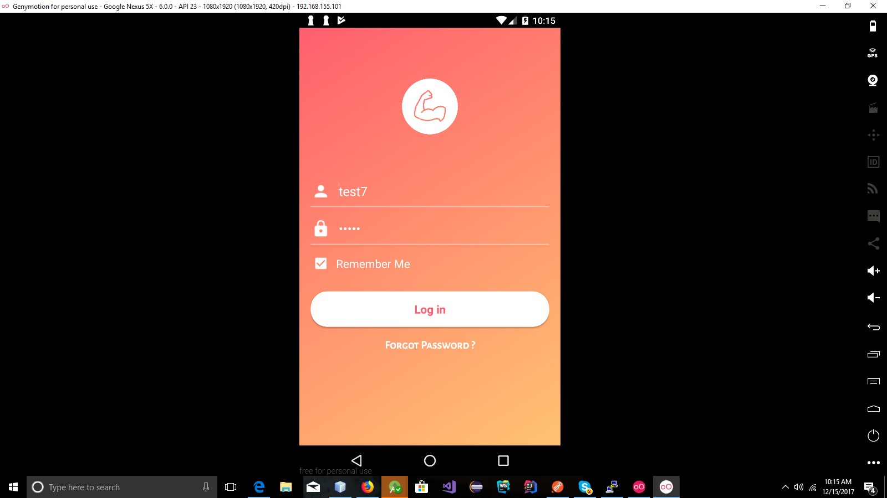

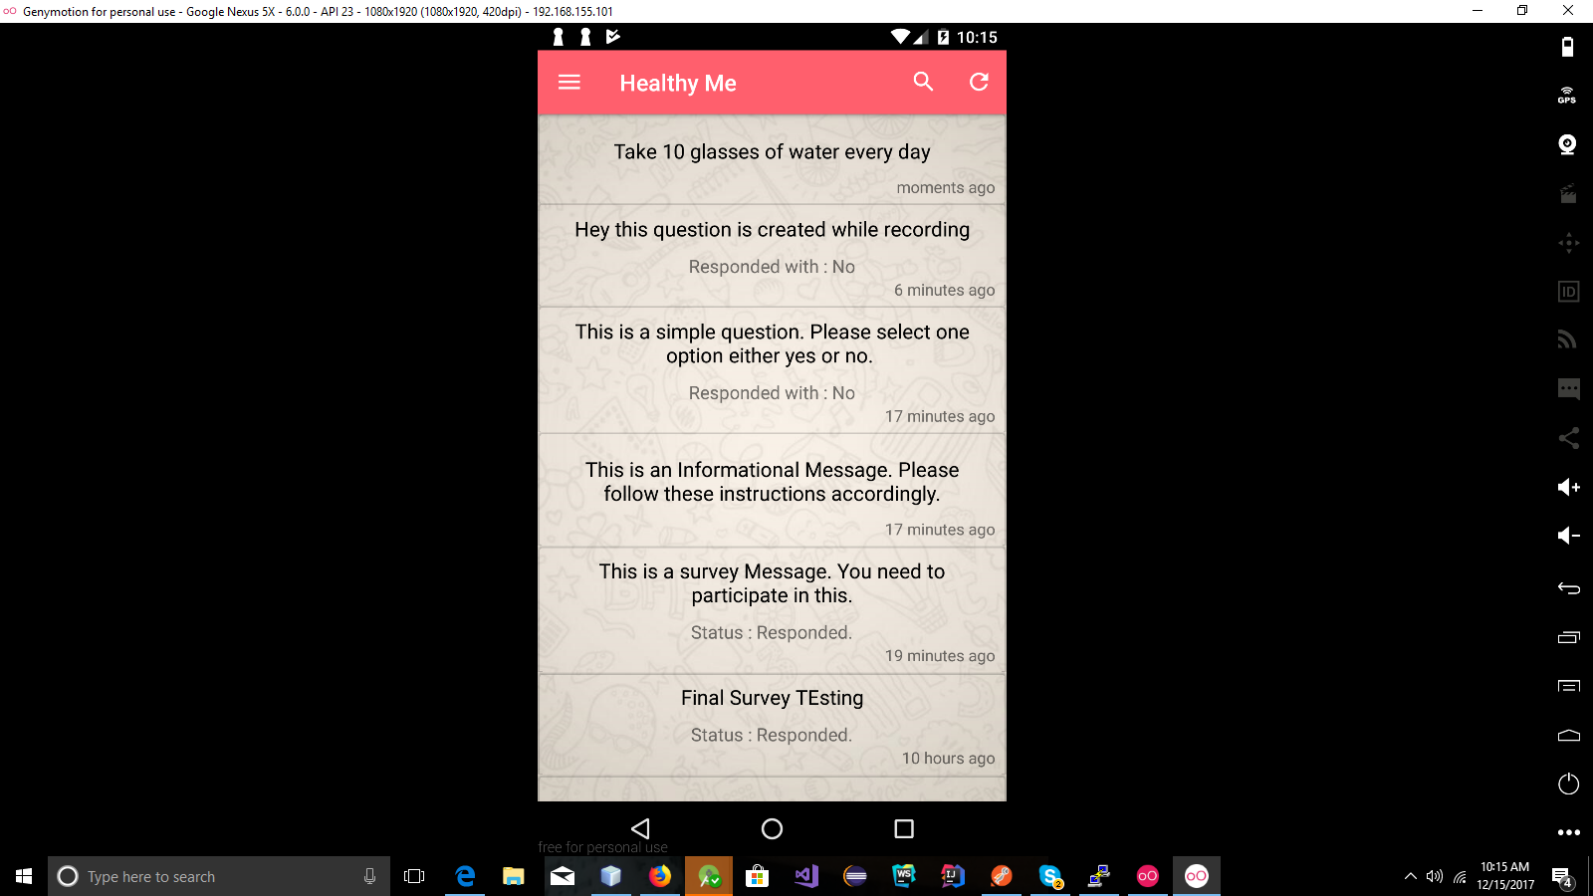

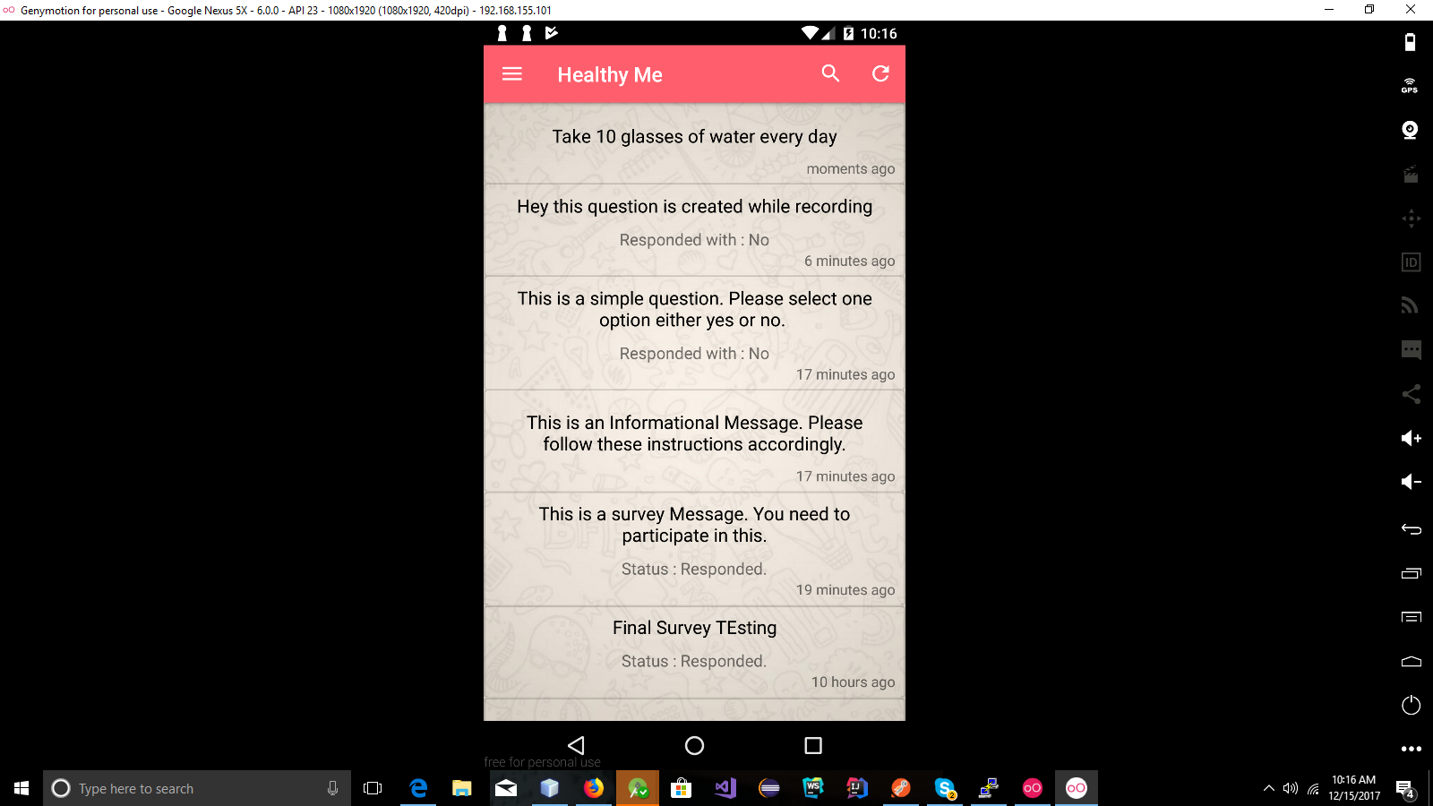

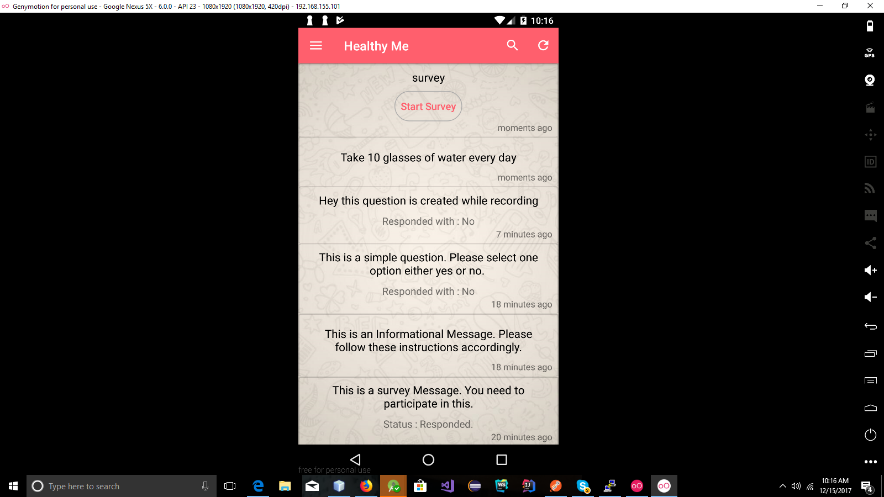

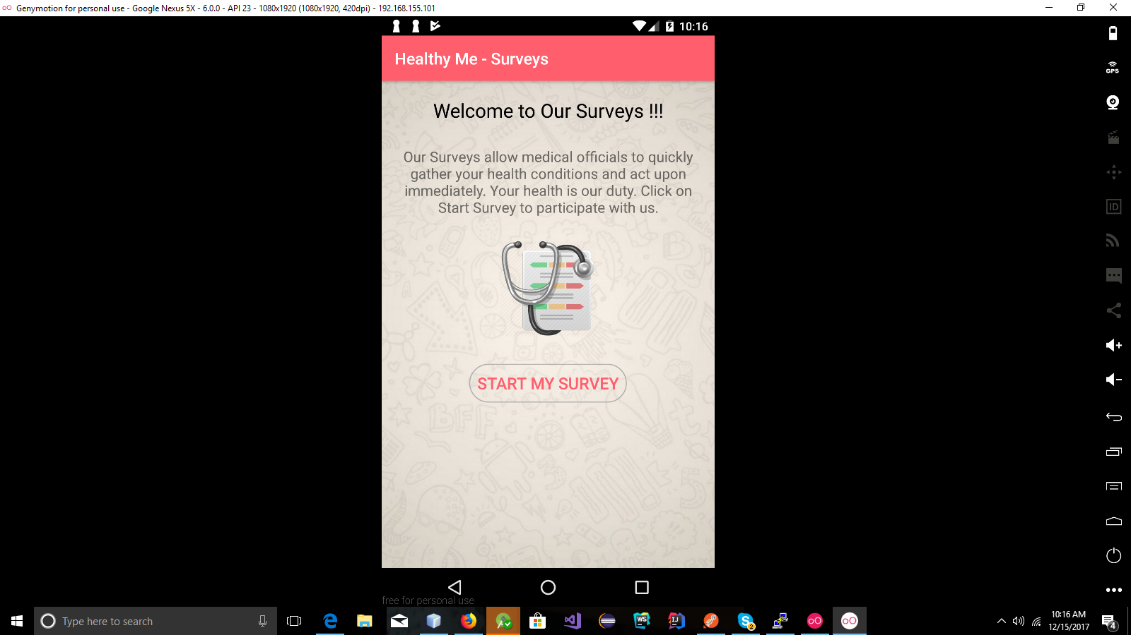

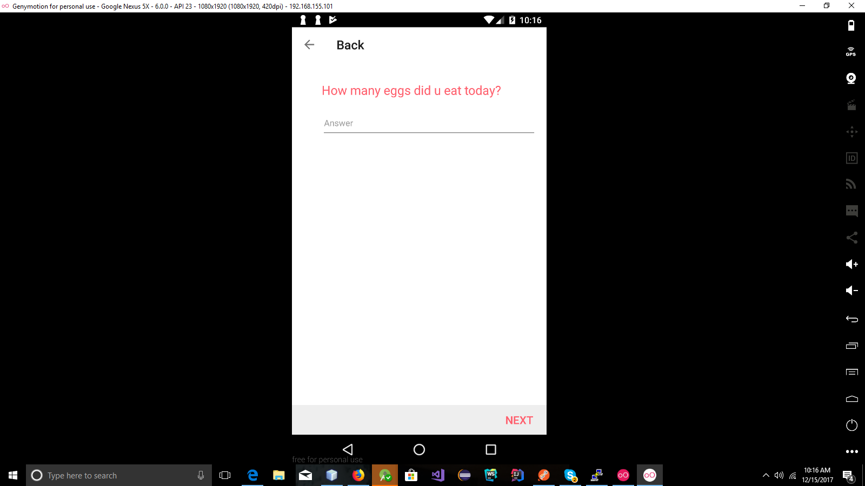

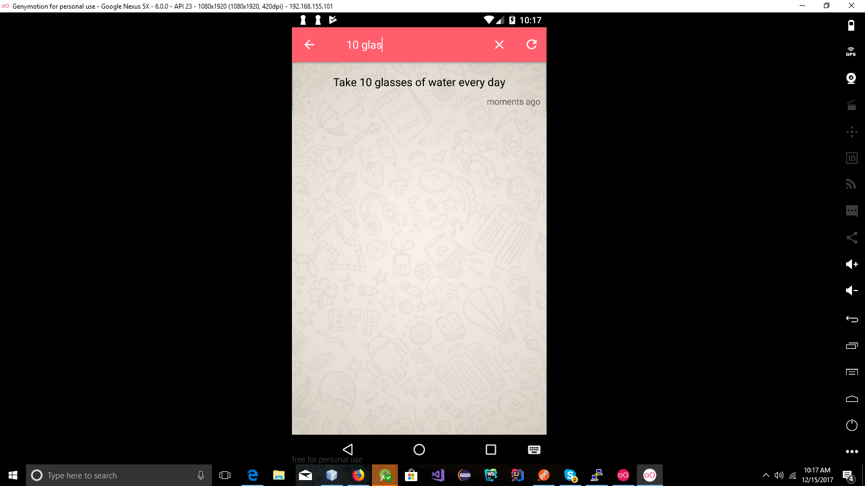

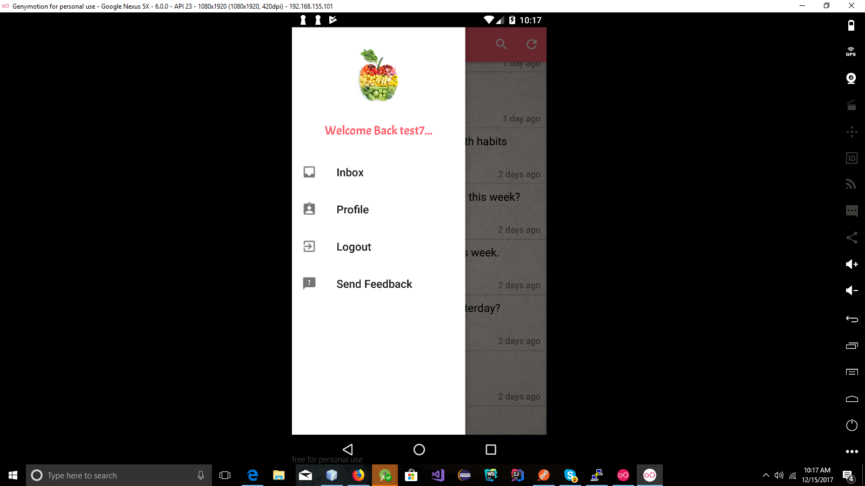

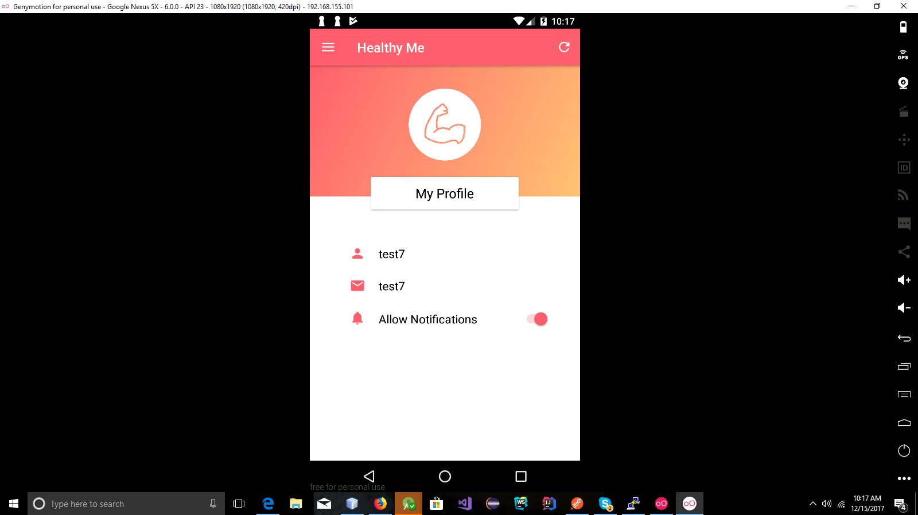

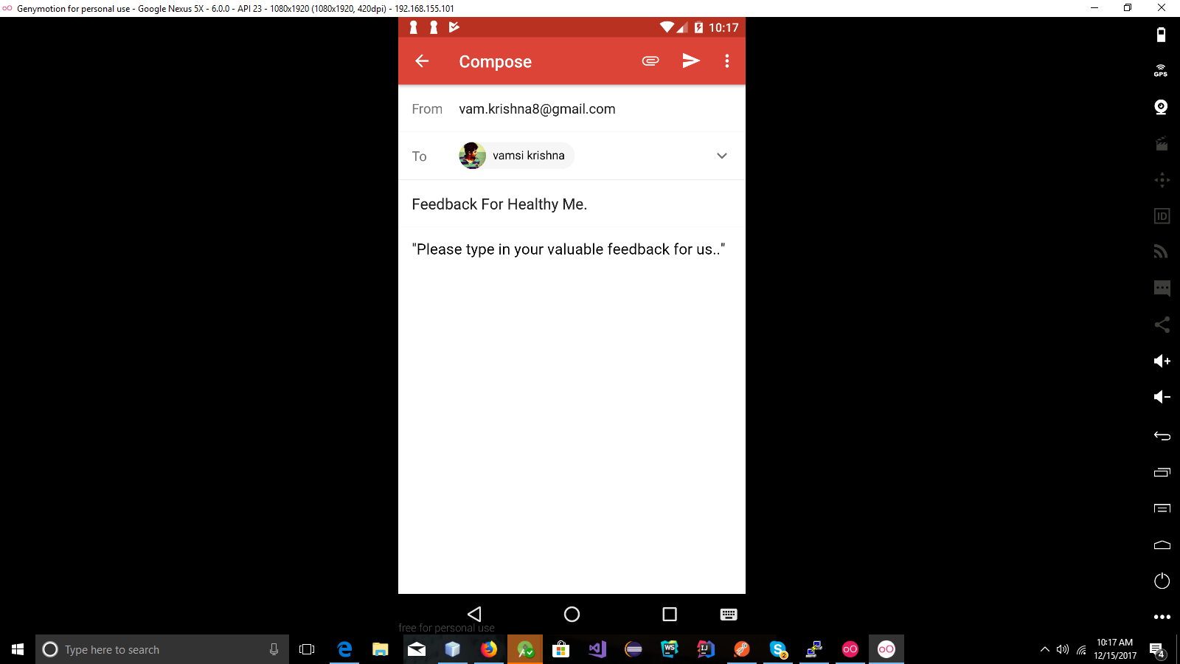

**Website Screenshots**

